Software Requirements Specification
for
Wilderness Weather Station
Version 2.0
Prepared by Rowshni Tasneem Usha
CSE470, BRAC University
10 February, 2019
Table of Contents
Table of Contents ii
Revision History ii
1. Introduction 1
1.1 Purpose 1
1.2 Document Conventions 1
1.3 Intended Audience and Reading Suggestions 1
1.4 Product Scope 1
1.5 References 1
2. Overall Description 2
2.1 Product Perspective 2
2.2 Product Functions 2
2.3 User Classes and Characteristics 2
2.4 Operating Environment 2
2.5 Design and Implementation Constraints 2
2.6 User Documentation 2
2.7 Assumptions and Dependencies 3
3. External Interface Requirements 3
3.1 User Interfaces 3
3.2 Hardware Interfaces 3
3.3 Software Interfaces 3
3.4 Communications Interfaces 3
4. System Features 4
4.1 System Feature 1 4
4.2 System Feature 2 (and so on) 4
5. Other Nonfunctional Requirements 4
5.1 Performance Requirements 4
5.2 Safety Requirements 5
5.3 Security Requirements 5
5.4 Software Quality Attributes 5
5.5 Business Rules 5
6. Other Requirements 5
Appendix A: Glossary 6
Appendix B: Analysis Models 7
Appendix C: To Be Determined List 7

Revision History
Name | Date | Reason For Changes | Version
Rowshni | 02/02/2019 | Initialization | 1.0
Rowshni | 10/02/2019 | Including Modelio diagrams | 2.0

Introduction

Purpose
The purpose of this documentation is to build a wilderness weather station system to monitor the condition of climate and weather forecast in remote areas. Several hundred weather stations are to be deployed in remote areas and a collaborative software system is required to control and monitor weather conditions. The paper describes the requirements of the system end-users and also the type of service the software product will deliver.

Document Conventions

Intended Audience and Reading Suggestions

Product Scope

References
Ian Sommerville. Software Engineering, 10th edition, 1.3.3 A wilderness weather station, pp. 22-23.

Overall Description

Product Perspective

Product Functions
- Each of these instruments is controlled by a software system that takes parameter readings periodically and manages the data collected from the instruments. The weather station system measures weather parameters from a number of over a 24-hour period.
- The data management and archiving system collects the data from all of the wilderness weather stations. It carries out data processing and analysis and archives the data in a form that can be retrieved by other systems.
- The station maintenance system This system can communicate by satellite with all wilderness weather stations to monitor the health of these systems and provide reports of problems.
- It can update the embedded software in these systems.
- In the event of system problems, this system can also be used to remotely control a wilderness weather system.
- Each weather station is battery-powered and must be entirely self-contained. The weather station must include some mechanism (solar or wind power) to charge its batteries.
- All communications are through a relatively slow speed satellite link.
- Monitor the instruments, power and communication hardware and report faults to the management system.
- Manage the system power, ensuring that batteries are charged whenever the environmental conditions permit but also that generators are shut down in potentially damaging weather conditions, such as high wind.
- Allow for dynamic reconfiguration where parts of the software are replaced with new versions and where backup instruments are switched into the system in the event of system failure.
.

User Classes and Characteristics
Different user classes in this system are- Weather station system user, Database manager, Maintenance system user, Forecasting system.

Operating Environment

Design and Implementation Constraints

User Documentation

Assumptions and Dependencies

External Interface Requirements

User Interfaces
The weather station system users will have a user-interface which shows the readings collected from the hardware sensor or instruments to monitor the condition of wilderness. The data displayed will be processed to an understandable format of the raw voltage readings of the sensors. The user will be able to view temperature readings, wind speed, wind direction, ground and air temperature, barometric pressure and rainfall over a 24- hour period in real-time. The user interface for the maintenance system will display the condition of all other weather station. The UI will display if any communication is down or any problem is faced with any station. The user can also remotely access and control other wilderness weather stations.

Hardware Interfaces

Software Interfaces
The whole system is divided into many sub-system software such as- The weather station system software, Data-management system, Station maintenance system. The weather station system is an on-board system software which will collect data regularly given a period and perform initial processing of raw sensor readings. The system will also forward the information to another system called the data management system. The data management software will collect these initially processed data and analyze it. Then the software system will create a database to archive collected data from all the weather station systems. The data needs to be stored so that all other system can access the data when necessary. Another software is created for station maintenance system. The software will be connected to all the weather station system via a satellite system and establish communication for monitoring the health of every weather station system. The software will report on any abnormal activities among the system. The software will also handle data locally in case of system failure. The software can also remotely control all other weather stations and update embedded software in the system.

Communications Interfaces

System Features
4.1 The Weather Station System
4.1.1 Description and Priority
The weather station system will collect data from sensors periodically. This system is of highest priority. The risk of this system failing must also be prevented. The collected data should be transmitted from weather station to data management system from which all other system users can access the data.
4.1.2 Stimulus/Response Sequences
The system will request to read data from each and every sensor or instruments to collect wilderness weather data / parameters and perform initial processing to make the data readable and understandable for users. After collecting the data, the system will send the data to data management system for storage and archived data is accessible by all other systems.
4.1.3 Functional Requirements
    - Each station will measure and collect weather parameters from instruments.
    - Data of the wind speed and direction, the ground and air temperatures, the barometric pressure, and the rainfall will be measured over 24-hour period.
    - Software system will collect parameter readings periodically (for example, temperatures are measured every minute.)
    - Manage data and Perform initial data processing. For instance, Temperature measuring instrument will provide value in Voltage. The software will convert it into centigrade temperature using this formula: [(analog voltage in mV) - 500] / 10
    - Transmit collected data to data management system and provide accessibility of information for other systems.

Data Management System
4.2.1 Description and Priority
The data management system collects the data from all of the wilderness weather stations, carries out data processing, analysis and archives. The stored data is can be accessed by users of all other systems. The data is archived in a form that can be retrieved by other systems such as, forecasting system.
4.2.2 Stimulus/Response Sequences
The system will process data and perform analysis. The raw data is processed in a manner which is understandable by users. The user can request data from the data management system and retrieve necessary data and information. The system is responsible for data archiving and data management.
4.2.3 Functional Requirements
- The software will convert collected data from sensors into understandable values using suitable formulas.
- The system software will be responsible creating and managing databases.
- The process includes acquiring, validating, storing weather parameters.
- The data is processed in a form that can be retrieved by other systems, such as weather forecasting systems.

4.3 The Station Maintenance System
4.3.1 Description and Priority
The station maintenance system will communicate with all weather stations and monitor the system health and report back.
4.3.2 Stimulus/Response Sequences
The system will communicate via satellite with all wilderness weather stations to monitor the health of these systems and provide reports of problem. The system can also remotely control a weather system.
4.3.3 Functional Requirements
- Establish communication over satellite link and ensure transmission of information
when requested by the data collection system.
- Store information if communication fails and maintain data locally until
communication is established again.
- Run regular diagnostic tests of the overall system, Monitor the instruments, power,
communication hardware and report faults to the management system.
- Manage the system power, ensuring that batteries are charged whenever the
environmental conditions permit but also that generators are shut down in damaging weather conditions, such as high wind.
- Allow for dynamic reconfiguration where parts of the software are replaced with new
versions and where backup instruments are switched into the system in the event of system failure.
- The software can also remotely control all other weather stations and update
embedded software in the system.

Other Nonfunctional Requirements

Performance Requirements
The performance need to be precise. As each weather station has to collect data from instruments at a selected interval to measure climate condition, the data collection, processing, transmission and archiving system should perform well. The data should be stored against real-time.

Safety Requirements
Any kind of system failure should not cause any physical or economical damage.

Security Requirements

Software Quality Attributes

Business Rules

Other Requirements
Appendix A: Glossary
Appendix B: Analysis Models
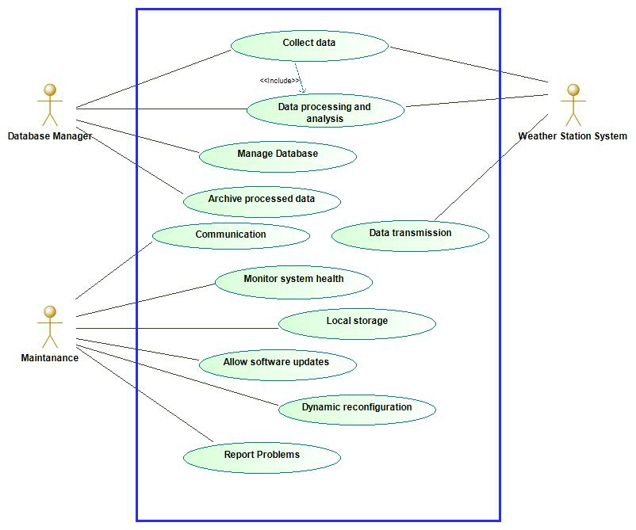

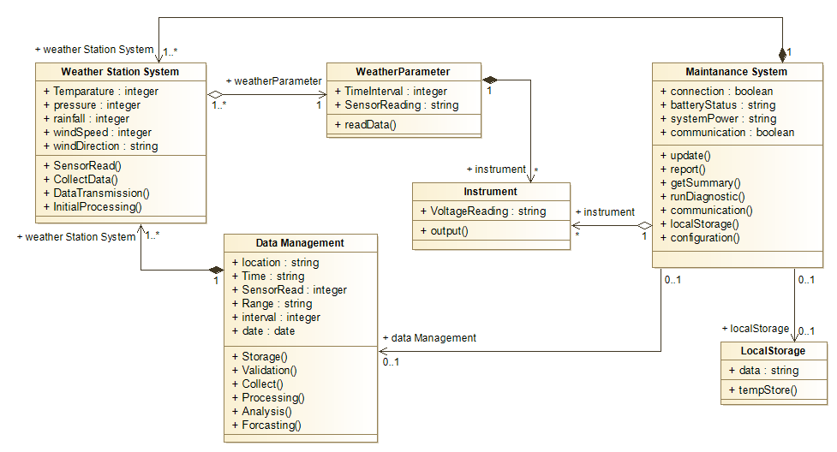

Appendix C: To Be Determined List

